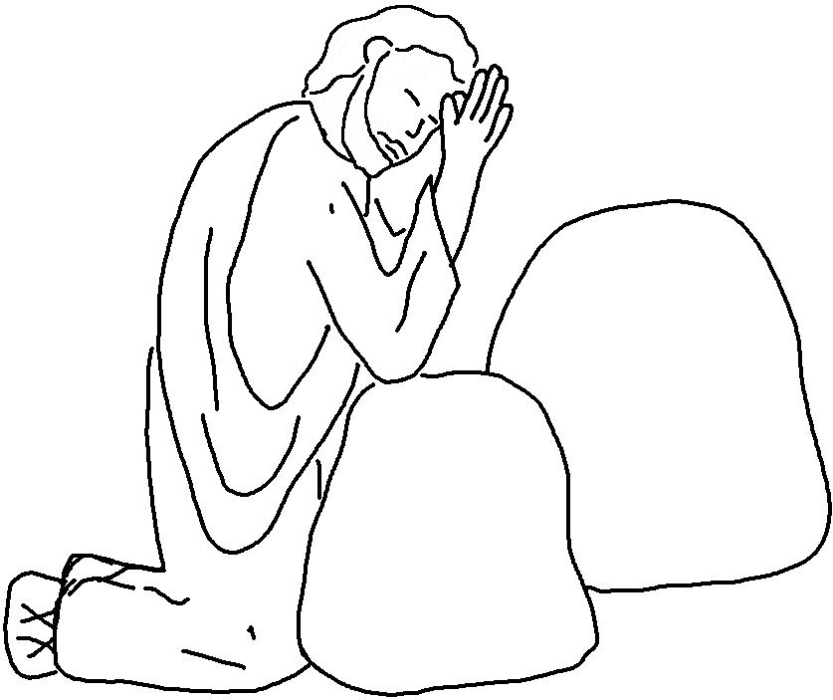
Our Father in _ _ _ _ _ _, may your name be kept holy.
May your Kingdom come soon.
May your will be done on earth, as it is in heaven.
Give us today the _ _ _ _ we need,
and forgive us our _ _ _ _,
as we have forgiven those
who sin against us.
And don’t let us yield
to temptation,
but _ _ _ _ _ _ us
from the evil one.

Matthew 6:9-13 _{NLT}

